# Literature Review

Summary

# Introduction

The European Programme for Mental health Exchanges Networking and Skills (EU-PROMENS) is a capacity-building programme on mental health by providing training and exchange between health professionals and other professionals. One of EU-PROMENS sub-tasks is to create, pilot, implement and evaluate a multidisciplinary training programme aiming at reinforcing competencies among the mental health workforces. The specific target groups of this training are *1) health professionals working in the mental health sector, 2) teachers and educators in educational settings, 3) social workers working in community settings, and 4) professionals working in prisons and juvenile detention centres*.

To create a consistent approach and training content for the multidisciplinary training programme a needs assessment served as the starting point. First, to align with the training gaps, obstacles, and needs for multidisciplinary learning content across all four target groups: *1) health professionals working in the mental health sector, 2) teachers and educators in educational settings, 3) social workers working in community settings, and 4) professionals working in prisons and juvenile detention centres.* Second, as the training programme adopts a multidisciplinary approach, it is key to gain clarity on existing and missing components of multidisciplinary mental health trainings for specialists and non-specialists in the field of mental health. Third, relevant, existing mental health trainings and their competency frameworks can serve as input for the learning objectives and training content of the training programme. Taking into account that a variety of different sector-specific competency frameworks, training programmes and modules focusing on mental health and psychosocial support exist in Europe and globally.

Therefore, the **main** objectives addressed by the study were:

* Understanding multidisciplinary needs, gaps, and obstacles in capacities, competencies, and training needs for professionals in health and in other settings contributing to mental health to design and develop the multidisciplinary training programme.
* Obtaining an overview of existing multidisciplinary training programmes and/or training modules for health professionals and professionals in other settings with mental health tasks.

# Methodology

To provide you with a complete picture the following steps are undertaken for the needs assessment, however in this document part 1 results are shared. **Part 1** consisted of a literature review of scientific articles and grey literature. **Part 2** consisted of a mixed methods study whereby qualitative and quantitative data were collected simultaneously, analysed separately, and thereafter triangulated. The qualitative elements consisted of focus group discussions and interviews (stakeholders' consultations), and the quantitative element was a survey. **Part 3** specifically focused on the mapping of existing training programmes and/or training modules (using the desktop review approach).

## Results

A total number of 7214 articles were retrieved, of which duplicates were removed (1604), after which 5610 articles were screened for the first round by title and abstract. The second round of screening was done on 508 title and abstracts and after full text screening in total 60 studies were included for data extraction and synthesis as displayed in Figure R1.

#### Towards Development of the Cross-Sectoral Mental Health Competencies Framework (review-based iteration)

Each type of profession connected to mental health support delivery mostly has its intra-professional competency framework (health and mental health professionals, education workers, social workers, and others). However, based on the data analysis from the literature review, several conclusions can be drawn about moving towards a comprehensive multidisciplinary approach to mental health.

**First,** despite the differences, cross-cutting, cross-disciplinary competencies are present in most specialised frameworks, e.g. "theories on (inter-, multi-, trans-) disciplinary teamwork / cooperation / collaboration / group dynamics and leadership" for psychologists, "mental health stigma reduction" for teachers, “Ability to deliver psychologically informed care" for paediatricians etc.

**Second**, there are already pre-developed competencies frameworks suitable for multidisciplinary teams of professionals engaged in mental health support, e.g., the "Sunnybrook framework of the core competencies for interprofessional team collaboration” (Australia), “the Advanced Practice Mental Health Curriculum and Capabilities Framework" (UK), or "the Mental Health Competency Framework for Health and Social Care Workers in Community Care Sector” (Singapore).

**Third**, most of the development concerning the development/focus on multidisciplinary competencies happened outside the EU and Europe. Considering the rich and diverse cultural context of Europe, this makes most of these frameworks unsuitable for immediate implementation.

#### Competency domains

Based on the content and structure of the reviewed competencies in the included articles of the litrature review, four main competency domains were constructed:

* **Foundational mental health competencies** - basic helping skills, knowledge, skills, and attitudes related to the essence of mental health support relevant to professionals from all sectors.
* **Intersectoral mental health collaboration/communication competencies** – competencies related to collaborating with professionals outside their sectors, initiating, leading or involving in this collaboration at different levels.
* **Multidisciplinary mental health team collaboration competencies**—collaborating with different professionals within multidisciplinary teams or services/organisations/sectors.
* **Specialised mental health competencies** — competencies specific to mental health care professions—are developed inside the health sector and relevant to specific job functions. Although these competencies are emphasized, they are outside our scope of work and, therefore, not targeted in this Framework.

Visualisation of the Cross-Sectoral Mental Health Competencies is provided in Figure R3 in the pyramid form. It reflects the idea of coverage by competencies of different professionals: ***foundational mental health competencies*** must be present in **all professionals** related to mental health; **most of them**, but not all, are to cooperate with services outside of their sector, therefore, in need of ***intersectoral mental health collaboration/communication competencies;* only part of the rest** are members of the multidisciplinary teams, and therefore in need of ***multidisciplinary mental health team collaboration competencies;*** and only **small amount** of all workforce is directly working in mental health (psychiatrists, clinical psychologists, psychiatric nurses, peer support workers etc.), and in need of ***specialised mental health competencies***.

This pyramid is developed in line with the WHO Model of the optimal mix of services. It can also reflect the costs needed to prepare professionals with those competencies: the higher the competencies are located in the model, the higher the costs and lengths of training (short training courses implemented via Continuous professional development for ***foundational mental health competencies*** and years of specialised Training for ***specialised mental health competencies).***   
  
Further, each Domain of the competencies is described in detail, including the descriptives (Behaviour, application, abilities) needed to implement the competency in question. Figure R3 presents a visualization. The full list of competencies, developed as the first review-based iteration before aligning with the data from interviews and focus groups, is presented in the relevant Annex.

***Foundational mental health competencie***s, such as basic helping skills, mental health knowledge, skills and attitudes related to the essence of mental health support that are relevant to professionals from all sectors, encompass six competencies:

###### Foundational Helping Skills

Foundational Helping Skills are already refined in the EQUIP (WHO, UNICEF) and can operationalised via Non-verbal communication & active listening; Verbal communication skills; Explanation and promotion of confidentiality; Rapport building & self-disclosure; Exploration & normalisation of feelings; Demonstration of empathy, warmth, & genuineness; Assessment of harm to self, harm to others, harm from others & developing collaborative response plan; Connection to social functioning & impact on life; Exploration of client’s & social support network’s explanation for the problem (causal & explanatory models); Appropriate involvement of family members & other close persons; Collaborative goal setting & addressing client’s expectations; Promotion of realistic hope for change; Incorporation of coping mechanisms & prior solutions; Psychoeducation & use of local terminology; Elicitation of feedback when providing advice, suggestions & recommendations.

###### Culture and Diversity Awareness

Culture-, age- and gender-sensitive skills and behaviours, such as respecting individual, cultural, and other diverse differences.

###### Mental Health Literacy

This competency is described via the knowledge about mental health, mental health problems and factors that contribute to the problems` development, understanding the impact of mental health problems on a person's life, and understanding the importance of timely and appropriate support for a person with mental health problems.

###### Mental Health Problems and Risks Assessment

Professionals equipped with this competency can identify the signs and symptoms of mental health problems, conduct assessments of mental health problems using reliable instruments, and assess the risks of self-harm and suicide.

###### Making evidence-informed impact

With this competency, professionals can conduct psychoeducation based on an understanding of the people's problems, deliver evidence-informed psychological support, and implement mental health promotion, advocacy, and stigma-reduction activities.

###### Self-care and care of colleagues/staff

This competency encompasses knowledge and skills such as understanding the importance of self-care, monitoring one's own stress level and recognising symptoms of fatigue, burnout, and mental health problems, using stress management, problem management, and self-care techniques regularly, identifying different ways to improve one's own well-being, being attentive to colleagues, recognising problems, and providing sensitive support to them.

###### Supporting Recovery

This competency at the primary level describes such behaviour and attitudes as respect for persons with mental health issues as individuals, their inherent worth and importance, enabling Persons with Mental Health Issues to Lead a Meaningful Life via recognition of their needs and strengths and encouraging them to participate in social and other activities, recognition the rights of persons with mental health issues to exercise self-determination, and personal control, make decisions and grow through experiences.  
  
   
  
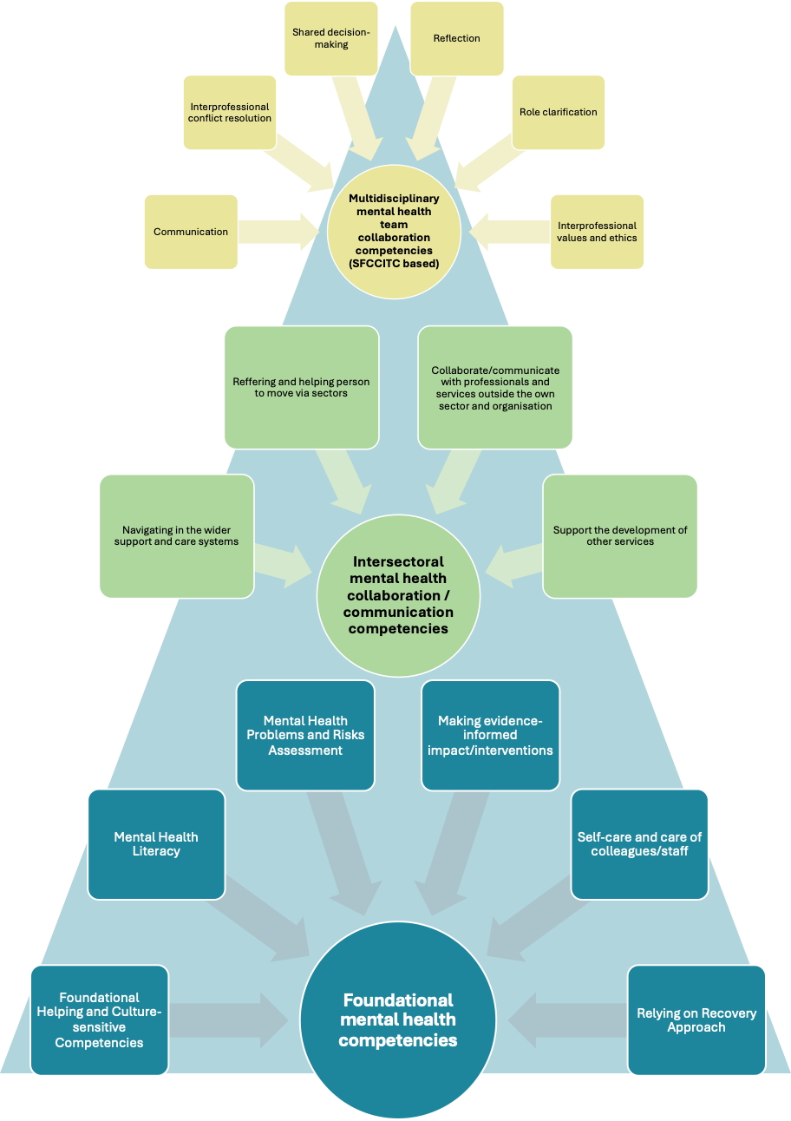  
**Figure R3. Pyramid of** **Cross-Sectoral Mental Health Competencies (detailed, without specialised Domain)**

***Intersectoral mental health collaboration / communication competencies*,** related to engaging in collaboration with professionals outside of their sectors, initiating, leading or involving in this collaboration at different levels, encompass four competencies:

###### Navigating within the wider support and care systems

This competency refers to understanding the role of other health, social care, education, and other sectors` services in supporting people with mental health problems; understanding the local care system, options, pathways, and how to access different parts (including agencies/organisations outside of one's own sector); and knowing of different approaches to mental health support organisations in other countries and contexts, best practices, and models.

###### Referring and helping people to move via sectors

This competency refers to making safe and sensitive referrals to relevant services, respecting the needs of the person with mental problems, supporting the person's move between care settings/sectors, and mitigating the risks of the person being overwhelmed by the complexity of systems.

###### Collaborate/communicate with professionals and services outside their sector and organisation

Such behaviours are foreseen: lead/coordinate effective intervention, incorporating collaboration with a range of professionals and agencies across organisational boundaries, including persons` close environment and the person themselves; deliver care and support in partnership with individuals' social support networks, health, social, and other services, ensuring a timely and cooperative response to their needs; use clear and accessible language across roles and professions, avoiding jargon and acronyms non-familiar to other professionals while providing explanations and confirming understanding.

###### Support the development of other services

The last competency encompasses such behaviours as creating a collaborative environment among different care professionals, proposing ideas for improving care for persons with mental health problems and sharing best practices, approaches, and models of mental health support with partners.

***Multidisciplinary mental health team collaboration competencies*** –competencies related to the collaboration of different professionals inside of the multidisciplinary team. We adopted the most developed Sunnybrook framework of the core competencies for interprofessional team collaboration (SFCCITC) for this set of competencies. It encompasses six core competencies that are relevant to team leaders and team members as well:

###### Communication with professionals of their team

Such behaviours are foreseen: developing processes for exchanging information in a specific and timely manner—within and across teams; explicitly considering which members need to be involved in giving and receiving which pieces of information; communicating using language that is common among roles and professions by avoiding jargon and acronyms, providing explanations, and checking for understanding.

###### Interprofessional conflict resolution

Such behaviours are foreseen: proactively and effectively addressing team conflicts within and across teams; listening open-mindedly to differing opinions and ideas from diverse roles and professions; discussing complex team issues; and arriving at mutually agreed-upon solutions.

###### Shared decision-making

This competency refers to creating and implementing interprofessional care plans that reflect what is most important to patients and families/customers; deciding collaboratively on learning goals that are shared across roles and professions; and identifying and designating accountability for all aspects of the work, particularly where there is role overlap.

###### Reflection

This competency refers to such professionals` skills and behaviours: dedicating time to ongoing team reflection; developing processes and tools to support ongoing team reflection; identifying successes and gaps regarding their collaborative work and celebrating or strategizing accordingly; and using concepts of team development and team dynamics to appraise how they are doing collectively.

###### Role clarification

This competency refers to such professionals` skills and behaviours: members are able to articulate their role and/or scope of practice to others on the team; members actively seek understanding of the roles of others on their team; members recognize their limitations and consult with one another appropriately based on knowledge, skills, roles, and scopes.

###### Interprofessional values and ethics

Such behaviours are foreseen: members speak with positive regard when discussing other roles and professions; create a safe environment for all members to speak up and advocate as necessary; consider the values and ethics of the organization, regulatory bodies, and individual members in team discussions.